Designing Experiments using Bloom Filters

C. Ian Philpot

Microsoft Corp.

Author Note

Reviewed by: James Taylor - Brenau Univ., Danny Garber - Microsoft

Table of Contents

[Abstract 3](#_Toc3870714)

[Designing Experiments using Bloom Filters 4](#_Toc3870715)

[Bloom Filters 4](#_Toc3870716)

[Bloom Filter Internals 5](#_Toc3870717)

[Bloom Filter Factors 6](#_Toc3870718)

[Description of Variables in Experiments 8](#_Toc3870719)

[One Factor at a Time Experiments 9](#_Toc3870720)

[Factorial Experiment 10](#_Toc3870721)

[References 17](#_Toc3870722)

[Footnotes 18](#_Toc3870723)

[Tables 19](#_Toc3870724)

[Figures 20](#_Toc3870725)

Abstract

With the proliferation of computing resources, machine learning models, and tooling many today do not spend time understanding the domains and factors that make up the underlying data used to create a modern artificial intelligence. The cloud has not only abstracted away many of the fundamental technologies but is also removing the need for prioritizing the factors or variables that we experiment with. A lot of trial and error work goes into creating models used to predict, decide, or classify entities in our problem domains. While there will always be some of this guess work to boot strap experimentation, a better understanding of the factors that make up our problem space, their importance, and interactions can help us to train models or just better solve problems faster and at a lower cost.

Keywords: Experimentation, Machine Learning, Artificial Intelligence, Bloom Filters

Designing Experiments using Bloom Filters

In today’s computing landscape utility computing and layers of abstraction reduce the complexity of creating scientific, advanced decision, or prediction software. This leads to a lack of understanding how these work in modern computing. In this repo our focus is on the underlying data and factors that go into creating machine learning models. Most of the work creating an ML model is spent scrubbing the data and getting it into a shape that it can be processed. This data is then used to train a model. Due to the utility and ubiquity of computing resources today, there is not a lot of thought going into how the data is best used while training a model.

Through a simple, statistically based approach to experimentation we can better understand the factors that make up our data. This will give better understanding to how and why are models are either working or failing. The advanced nature that makes up modern algorithms and computing infrastructure it takes to understand much of the work being done today, we will focus our work on Bloom Filters. This probabilistic data structure is very well understood and gives us a known target to demonstrate how to create experiments that can be applied to many of the problems that face us today. These experiments are only to explore the process of experimentation and not necessarily to learn anything new about this data structure.

# Bloom Filters

Bloom filters are a probabilistic data structure created in 1970 by Burton Bloom. It is used to test if an entity is found within a set. False Positive matches can and do occur, but false negatives do not. This means for the user that an item is possibly in the set, or it is not. Because of this, it has very specific use cases, but can drastically increase the speed or scale of a system ([Wikipedia](https://en.wikipedia.org/wiki/Bloom_filter)).

## Bloom Filter Internals

An empty bloom filter is a bit array of size “m” all set to zero.

empty_bit_array

When an item is added it is hashed “k” number of times. In this example k = 3.

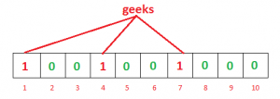

More items go through the same process.

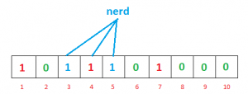

Finally, when a look up is done, some items can cause false positives due to collisions in hash functions.

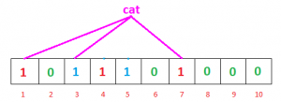

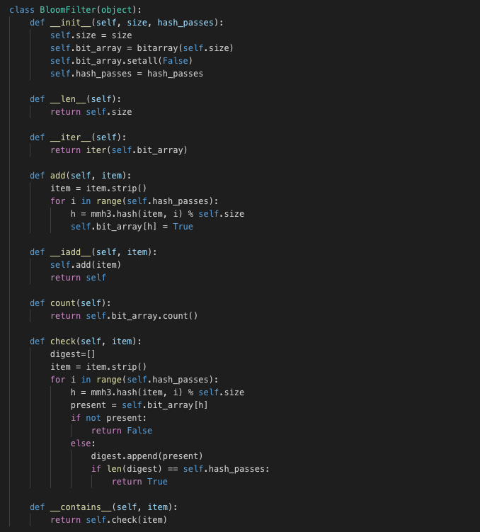

Figure 1: Bloom Filter Class

The code in Figure 1 shows both how to insert items (add method) and how to query for items (check method). These are referenced by the “\_\_iadd\_\_” and “\_\_contains\_\_” or special methods in python. This is to follow pythonic convention and enable code reuse.

## Bloom Filter Factors

There are three main factors we can use to efficiently and effectively store and test for items in a set using Bloom Filters.

* Probability of false positives
  + Let false positives be “p”



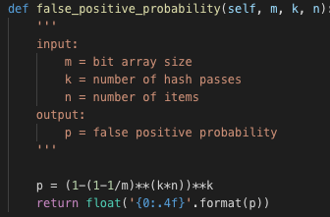

Figure 2: False Positive Probability

* Size of the bit array
  + Let bit array size be “m”



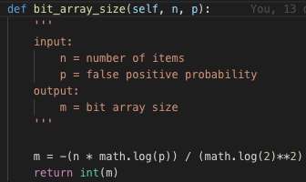

Figure 3: Bit array size

* Number of hash functions or passes
  + Let hash function pass count be “k”



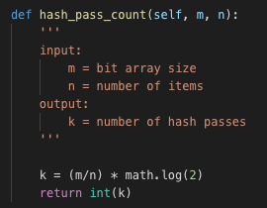

Figure 4: Hash Pass Count

These equations are used to understand the settings needed to configure a bloom filter to store “x” number of items ([GeeksforGeeks](https://www.geeksforgeeks.org/bloom-filters-introduction-and-python-implementation/)).

Another factor that we are able to control is the type of hash function used. Our experiments hold this constant using the mmh3 pip package to provide this functionality.

# Description of Variables in Experiments

For our experiment we will be inserting 10,000 items (usernames) into our bloom filter. Using the above equations, we can right size our bloom filter with the following factors:

1. 10,000 Items inserted
2. 1,000 Absent items to test with
3. Bit array size: 62352
4. Hash pass count: 4
5. Target false positive rate: 0.05

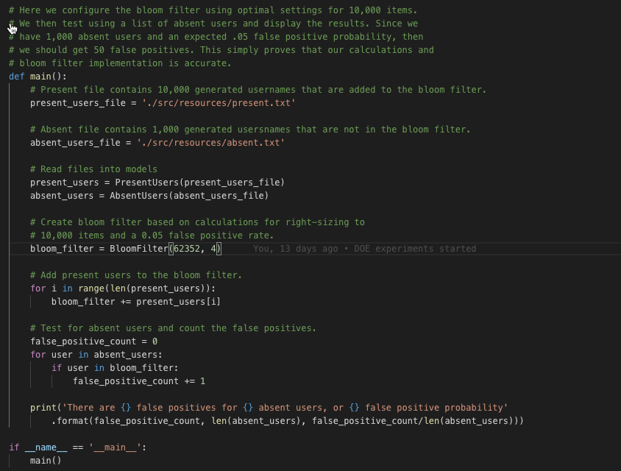

Figure 5: Right Sized Bloom Filter Test

# One Factor at a Time Experiments

A common strategy of experimentation is One Factor at a Time (OFAT) type of experiments. The experimenter selects a starting point, or baseline, for one of the controllable factors then varying it while holding all other factors constant. After all the experiments are completed a set of graphs are made to show how the response variable changes. “The major disadvantage of the OFAT strategy is that it fails to consider any possible interaction between the factors.” ([Montgomery, D. C.](https://www.wiley.com/en-us/Design+and+Analysis+of+Experiments%2C+9th+Edition-p-9781119113478)).

An interaction causes the response variable to differ when testing a controllable variable at varied levels of the other controllable variables. Understanding this and the effect that this interaction has on our experiments, will help us focus on the factors that are most important when training machine learning models or solving complex problems using other data analysis methods.

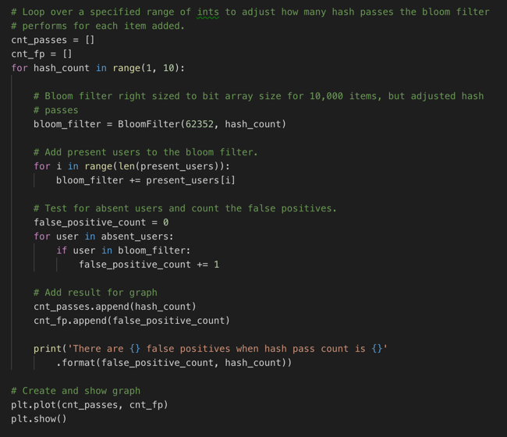

Figure 6: OFAT Hash Pass Count

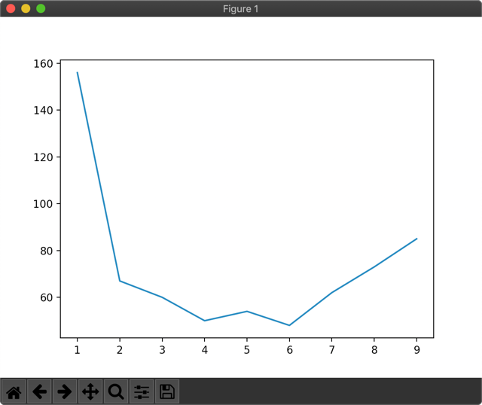

Figure 7: OFAT Hash Pass Count Effect

Figure 1 shows a code snippet where we are conducting a OFAT experiment varying only the count of hash passes used to insert items into the bloom filter’s bit array. Figure 2 is a graph of the effect this has on the response variable: false positives. From this we see that when all other variables are fixed, false positives are minimized at 4 and 6 hash passes. This is suspect because when other factors are changed, we may get different results and interactions are not detectable.

# Factorial Experiment

The goal of a factorial experiment is to “turn the knobs” of all the factors being tested and understand the effect and interactions each have on one another. The major advantage is that using these techniques we can utilize all of the data gathered to determine how best to work with the factors when building machine learning models or solving problems considered complex.

For our Bloom Filter, we are designing a 2-factor factorial experiment. Our controllable variables will consist of the Bit Array size and Hash pass count. All other variables will be held constant using the right-size configuration for our bloom filter. I would like to point out that bloom filters and their factors are a known quantity. As mentioned previously, these experiments are only to explore the process of experimentation and not necessarily to learn anything new about this data structure.

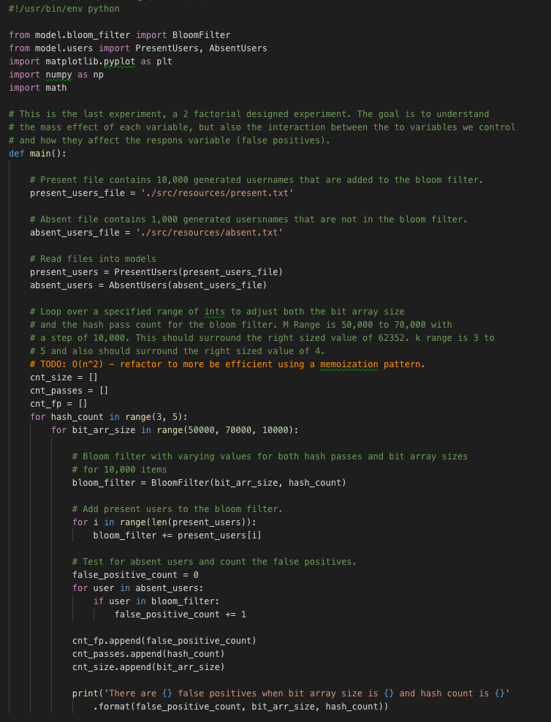

Figure 8: 2-Factor Factorial

The code found in Figure 8 is in the file 05\_doe\_fact\_all.py and will drive the experiment. Since we already have the answers to what the settings are for right-sized bloom filter, we establish the factor experimental levels so as to gain the greatest amount of information with the fewest number of experimental runs. For hash pass counts we use 3 and 4. For bit array size we use 50,000 and 60,000. In this experiment we will only do one pass. There is no variation in the response variable between runs, so we know the output is statistically significant. Otherwise we would employ additional techniques to assess if the results are statistically significant.

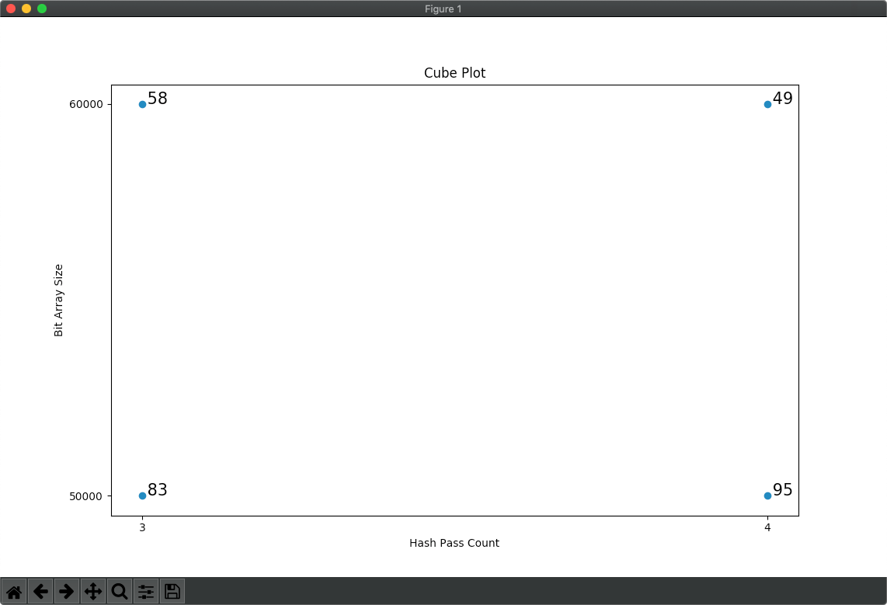

Figure 9: Cube plot showing response variable

The cube plot in Figure 9 shows a 2-factor experiment. The plot has each factor at different levels and each combination shown. This creates a 2-d square where a 3-factor experiment would create a cube. The different combinations for further analysis will be derived from this plot.

To understand the main effect that the hash pass counts have on our experiment we will take the average of these and plot them. The data from our cube plot would look something like:

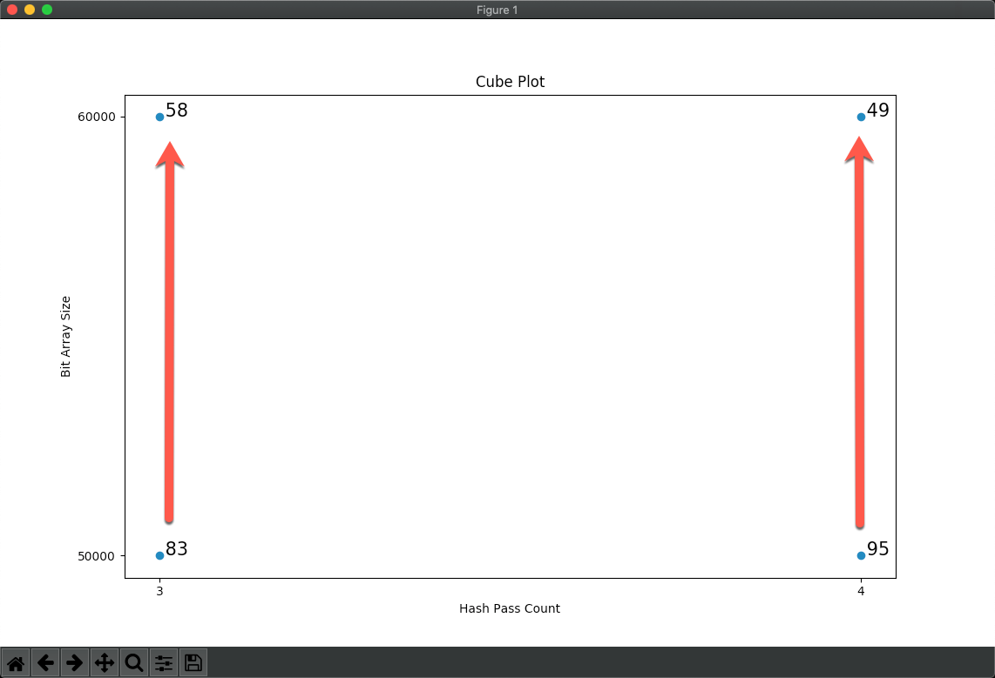

Figure 10: Hash Pass Main Effect Cube Data

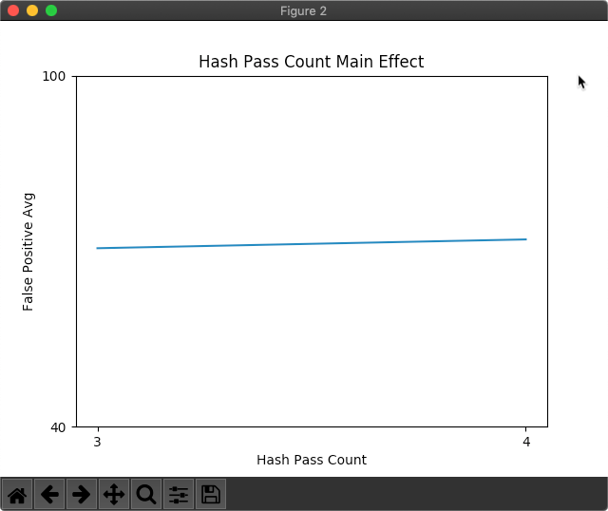

Figure 11: Main Effect Graph of Hash Pass Count

The main effect for hash passes is 1.5

This is found by taking the averages of the two runs and finding the difference: ([83+58]/2)-([95+49]/2) = 1.5

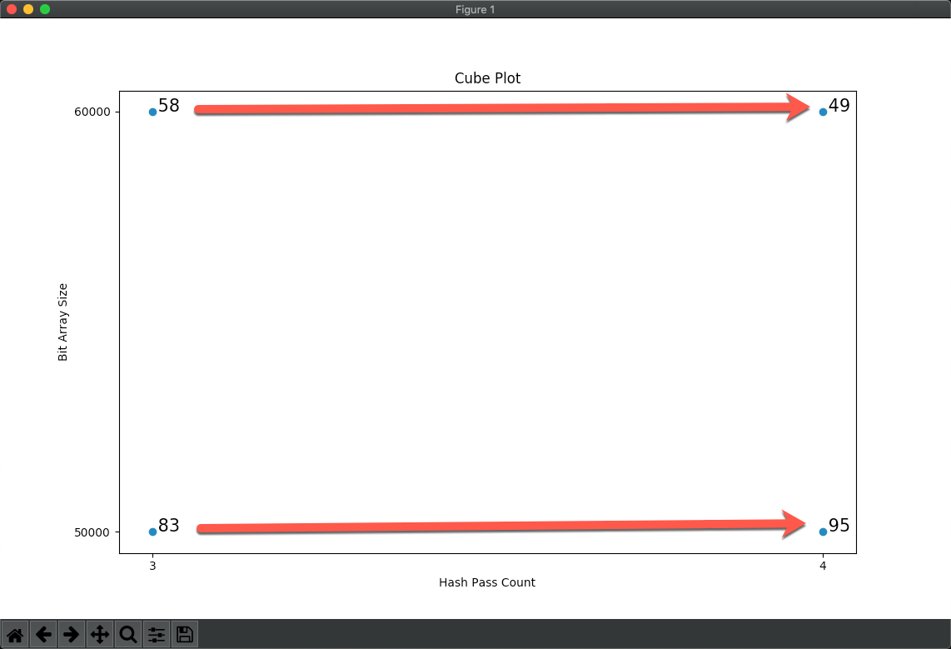

Figure 12: Bit Array Main Effect Cube Data

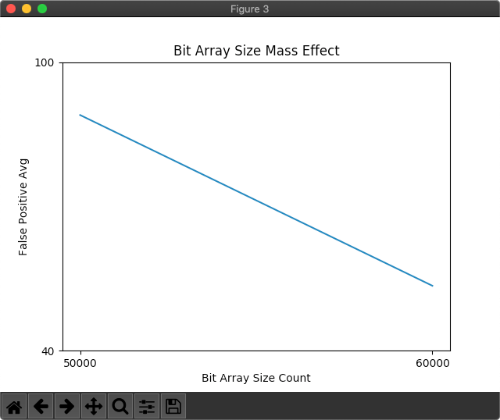

Figure 13: Main Effect Graph of Bit Array Size

The main effect for bit array size is 35.5

Similarly, this is found by taking the averages of the two runs and finding the difference: ([83+95]/2)-([58+49]/2) = 35.5.

From these two graphs we see that both effect the response variable, but that the bit array size has a more significant effect.

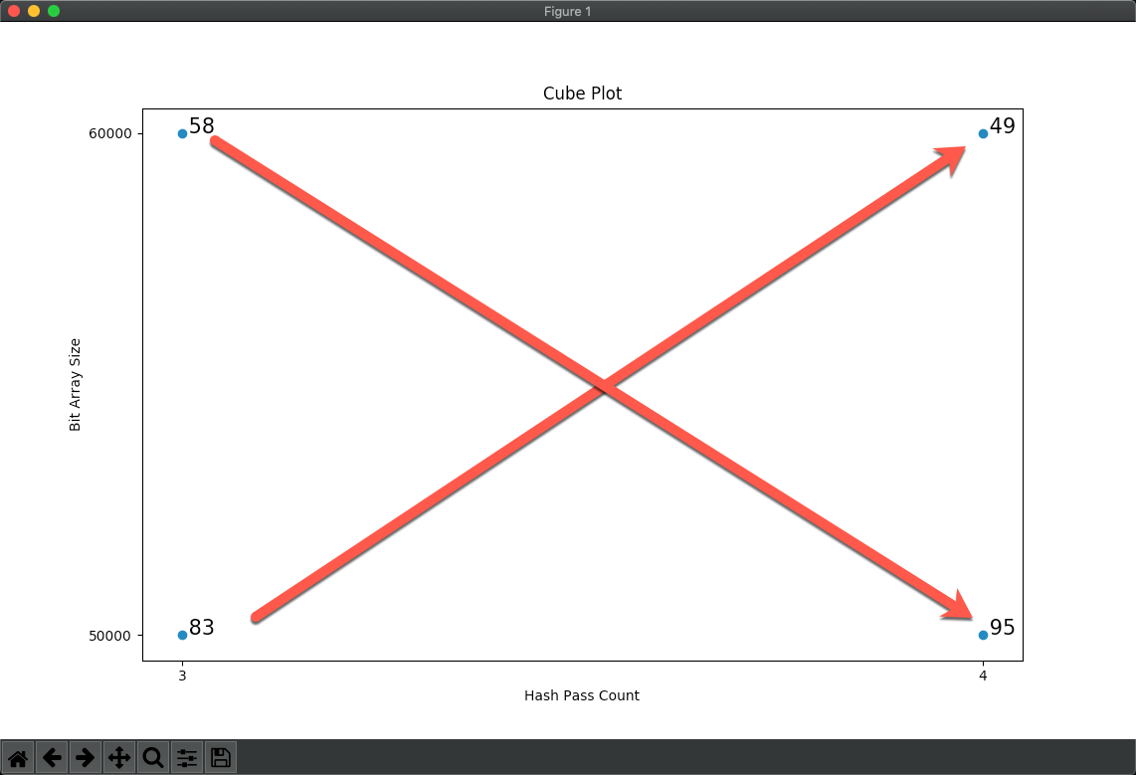

Figure 14: Interaction Effect Cube Plot Data

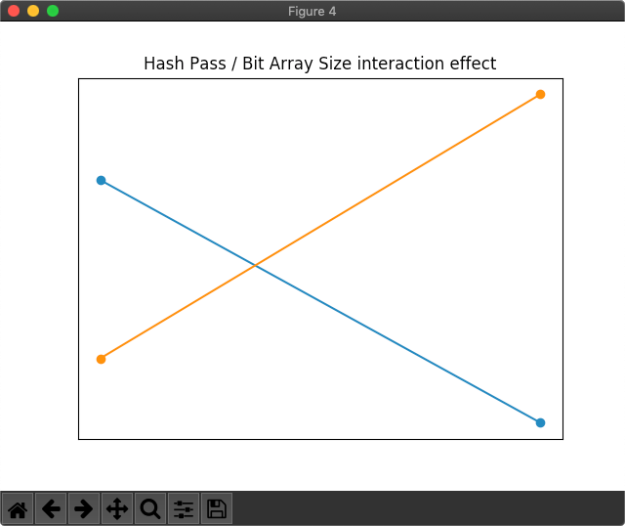

Figure 15: Interaction Effect Graph

The Hash Pass / Bit Array Size interaction effect is 10.5

The hash pass / bit array size interaction effect is obtained by taking the average false positives from left to right diagonal: ([83+49]/2)-([58+95]/2) = 10.5

From this we see that there is an interaction between the two as we’d expect. 10.5 is considered significant and would direct further experimentation to focus on the interaction. Each factor has an effect, but they also depend on the level of other factors. From this we see that when 4 hash passes are deployed, false positives are minimized with a 60000 bit array. Using these values and knowledge, we can create further experiments to find the optimal settings for each factor. Adjusting the “knobs” in relation to the main and interaction effects found.

# Conclusion

The idea for this study is not to use Bloom Filters for anything other than simply a data structure to experiment with. We could've used anything in its place, but it turned out to be a great example. And fun to learn about.

The main point is how we modeled the experiment, the results, and the findings they drove. Ultimately bit array size (m) is more important than hash passes (k) and the interaction of both (m + k) is very significant. This supports the known properties of Bloom filters.

Applying this to an ML model or complex problems, we can decide what are the more important factors and how they interact, or if there is no interaction between the factors. This gives us an efficient starting point for training models or writing algorithms. Ultimately, we can hypothesize that we can reduce overall training time and costs using this method.

References

Montgomery, D. C. (2017) *Design and Analysis of Experiments, 9th Edition.* John Wiley & Sons

Footnotes

1[Add footnotes, if any, on their own page following references. For APA formatting requirements, it’s easy to just type your own footnote references and notes. To format a footnote reference, select the number and then apply the Footnote Reference. The body of a footnote, such as this example, uses the Normal text style. (Note: If you delete this sample footnote, don’t forget to delete its in-text reference as well.)]

Tables

Table 1

[Table Title]

|  |  |  |  |  |
| --- | --- | --- | --- | --- |
| Column Head | Column Head | Column Head | Column Head | Column Head |
| Row Head | 123 | 123 | 123 | 123 |
| Row Head | 456 | 456 | 456 | 456 |
| Row Head | 789 | 789 | 789 | 789 |
| Row Head | 123 | 123 | 123 | 123 |
| Row Head | 456 | 456 | 456 | 456 |
| Row Head | 789 | 789 | 789 | 789 |

Note: [Place all tables for your paper in a tables section, following references (and, if applicable, footnotes). Start a new page for each table, include a table number and table title for each, as shown on this page. All explanatory text appears in a table note that follows the table, such as this one. Use the Table/Figure style to get the spacing between table and note. Tables in APA format can use single or 1.5 line spacing. Include a heading for every row and column, even if the content seems obvious. To insert a table, on the Insert tab, tap Table. New tables that you create in this document use APA format by default.]

Figures

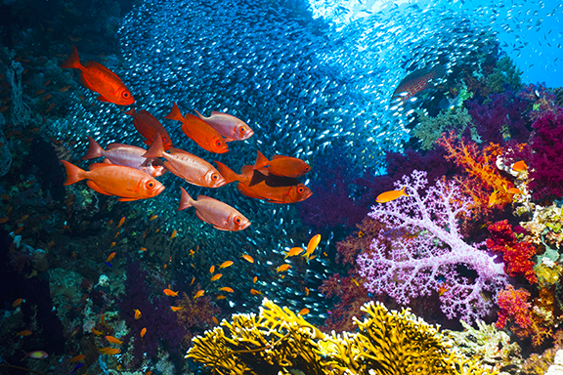

Figure 1. [Include all figures in their own section, following references (and footnotes and tables, if applicable). Include a numbered caption for each figure. Use the Table/Figure style for easy spacing between figure and caption.]

For more information about all elements of APA formatting, please consult the APA Style Manual, 6th Edition.